mAY

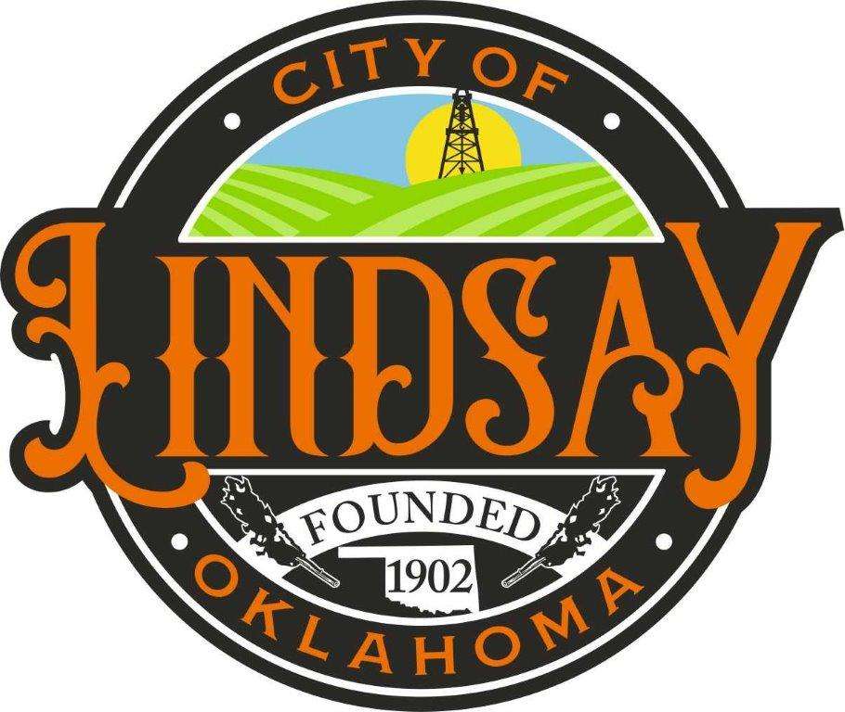

P O Box 708 312 S. Main Street
Lindsay, OK 73052
______________________________________________________
Dial 405-756-2019 Fax 405-756-8414

Website: cityoflindsay.com

All items on this agenda, including but not limited to any agenda item concerning the adoption of any ordinance, resolution, contract, agreement, or any other item of business, are subject to amendment, including additions and/or deletions. This rule will apply to every individual agenda item without exception, and without providing this same amendment language with respect to each individual agenda item. Such amendments should be rationally related to the topic of the agenda item, or the governing body will be advised to continue the item.

The governing body may adopt, approve, ratify, deny, defer, recommend, amend, strike, or continue any agenda item. When more information is need to act on an item, the governing body may refer the matter to its City/Trust Manager, staff, attorney or the recommending board, commission or committee.

AGENDA
Lindsay Public Works Authority (LPWA)
REGULAR MEETING
January 08, 2024
6:00 P.M.
(MEETING WILL BE HELD IN COUNCIL CHAMBERS AT 204 W. CREEK)

- CALL TO ORDER

- ROLL CALL

- CONSENT AGENDA
Discussion, consideration, and possible action on the CONSENT AGENDA: The following items are considered routine by the Lindsay Public Works Authority and will be enacted with one motion. Discussion desired on any item, that item will be removed from the Consent Agenda and considered separately.

  - APPROVAL OF MINUTES
Approval of the minutes of the Lindsay Public Works Authority Regular Meeting on December 11, 2023

  - ACCEPTANCE OF FINANCIAL REPORT
Acceptance of December 2023 Financial Reports.

  - ACCEPTANCE OF PURCHASE ORDER PAYMENTS
Acceptance of the payment of the purchase orders issued by the Lindsay Public Works Authority for the month of December 2023.

- CONSIDERATION OF ITEMS BEING REMOVED FOR CONSENT AGENDA
Approve or Reject

- UTILITY BILLING ISSUES
Discussion, consideration and possible action on utility billing issues, billing changes, changes in cut off (no longer hanging tags) and customer issues.

- WATER PLANT PROJECT
Discussion, consideration, and possible action on water plant project.

- METER ISSUES
Discussion, consideration, and possible action on meters, meter boxes, and customer issues

- ELECTRIC METERS
Update on electric meter installation

- GOVERNING BOARD COMMENTS

- CITY MANAGER REPORT AND UPDATE ON PROJECTS (No Action to Be Taken)

- ADJOURN

