mAY

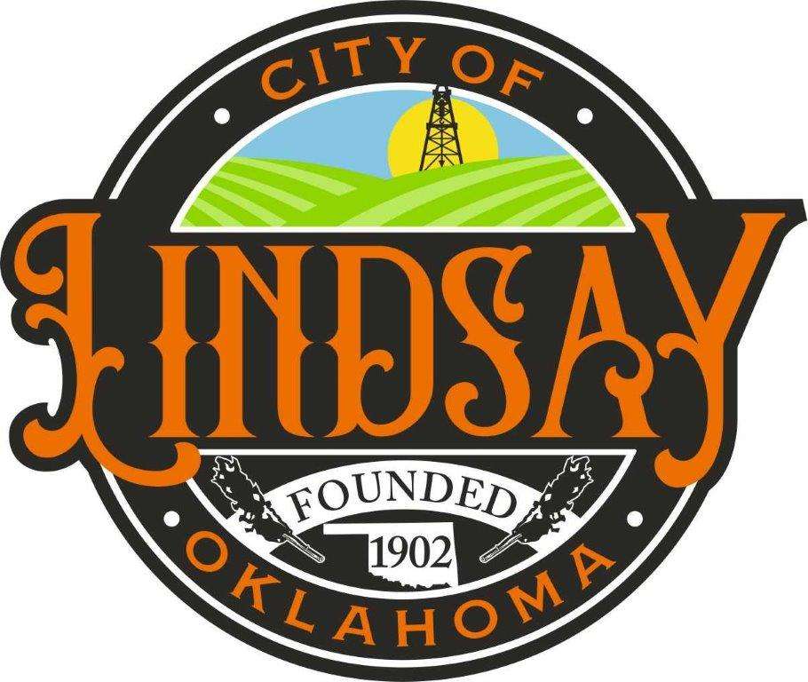

P O Box 708 312 S. Main Street
Lindsay, OK 73052
______________________________________________________
Dial 405-756-2019 Fax 405-756-8414

Website: cityoflindsay.com

All items on this agenda, including but not limited to any agenda item concerning the adoption of any ordinance, resolution, contract, agreement, or any other item of business, are subject to amendment, including additions and/or deletions. This rule will apply to every individual agenda item without exception, and without providing this same amendment language with respect to each individual agenda item. Such amendments should be rationally related to the topic of the agenda item, or the governing body will be advised to continue the item.

The governing body may adopt, approve, ratify, deny, defer, recommend, amend, strike, or continue any agenda item. When more information is need to act on an item, the governing body may refer the matter to its City/Trust Manager, staff, attorney or the recommending board, commission or committee.

AGENDA
CITY OF LINDSAY
REGULAR MEETING
JANUARY 08, 2024
6:00 P.M.
(MEETING WILL BE HELD IN COUNCIL CHAMBERS AT 204 W. CREEK)

- CALL TO ORDER

- INVOCATION

- PLEDGE OF ALLEGIANCE

- ROLL CALL

- CITIZEN COMMENTS: Anyone having an item of business to present to the Lindsay City Council are requested to sign in prior to the meeting and will be required to limit their presentation to three (3) minutes. Additionally, if more than one individual would like to speak on the same topic, the Council may request that a spokesperson be chosen to speak on behalf of the group. To ensure compliance with the Oklahoma Open Meeting Act no action will be taken on information received from Citizen Comments, nor will there be any feedback from the Council.

- CONSENT AGENDA
Discussion, consideration, and possible action on the CONSENT AGENDA: The following items are considered routine by the Lindsay City Council and will be enacted with one motion. Discussion desired on any item, that item will be removed from the Consent Agenda and considered separately.

  - APPROVAL OF MINUTES
Approval of minutes of the City of Lindsay Regular Meeting on December 11,2023

  - ACCEPTANCE OF FINANCIAL REPORTS
Acceptance of December 2023 Financial Reports.

  - ACCEPTANCE OF PURCHASE ORDER PAYMENTS
Acceptance of the payment of the purchase orders issued by the City of Lindsay for the month of December 2023.

  - PURCHASES OVER $5,000
Acceptance of the purchase orders over $5,000.

  - ZONING CHANGE ORDIANANCE 575
Approval of Ordinance 575

  - GARVIN COUNTY GEOSAFE RENEWAL
Acceptance of the GEOSAFE Memorandum of Understanding renewal.

- CONSIDERATION OF ITEMS REMOVED FROM CONSENT AGENDA
Approve or Reject

- DOBSON FIBER PROPOSAL
Discussion, consideration, and possible action on Dobson Fiber proposal for services provided to the City.

- ONLINE PAYMENT/WEBSITE SERVICE INFORMATION
Discussion, consideration, and possible action on online payment/website service information.

- TRAFFIC CONTROL DEVICES
Discussion, consideration, and possible action on traffic control devices.

- TREASURER
Ratify the acceptance by Lisa Lewis for the position of treasurer.

- JUDGE
Discussion, consideration, and possible action on appointment of the Judge

- CHANGING OR UPDATING THE CHARTER
Discussion, consideration, and possible action on changing or updating the charter

- CITY AND TRUST BOARDS
Discussion, consideration, and possible action on City and Trust Boards.

- COUNCIL PACKETS
Discussion, consideration, and possible action on getting council packets on Thursday.

- UNFORESEEN ITEMS (TITLE 25 SECTION 311 (A)(10)
Discussion, consideration, and possible action on unforeseen items

- EXECUTIVE SESSION ACTION
Discussion, consideration, and possible action to enter into Executive Session pursuant to 25 O.S. Section 307(B)(4) For confidential communications between the Council and its attorney concerning Garvin County case number CV-23-87, if the public body, with the advice of its attorney, determines that disclosure will seriously impair the ability of the public body to conduct the pending litigation in the public interest.

- RECONVENE MEETING

- EXECUTIVE SESSION ACTION
Discussion, consideration, and possible action on any matter discussed in Executive Session regarding Garvin County case number CV-23-87.

- GOVERNING BOARD COMMENTS

- CITY MANAGER REPORT AND UPDATE OF PROJECTS. (No Action To Be Taken)

- ADJOURN

